# How to run the program

Extract the airport-simulation-0.0.1-SNAPSHOT-package.zip. It should have following directories in it

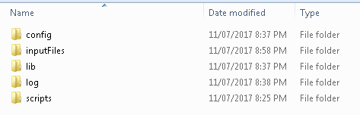

Go to scripts folder and run startup.bat or startup.sh depending on windows or unix system (you may have to run dos2unix startUp.sh ) respectively.

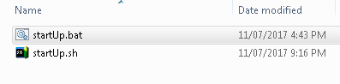

It should run and output will be like this

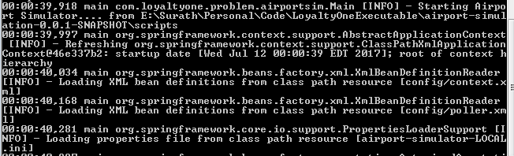

# Input of the program

Default input files are there in the inputFiles folder. User can create their own input files according to input file contains section

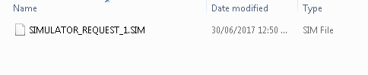

Input file location can be set using message.input.dir properties in the airport-simulator-LOCAL.ini file. Details are mentioned in Config Folder section.

# File Naming Convention

File name should be SIMULATOR_REQUEST_<NUM>.SIM.

This file naming convention can be set using 2 properties in airport-simulator-LOCAL.ini : message.input.format & message.input.format.regex.

Details are mentioned in Config Folder section.

# Input File Contains

Input file should contain JSON in below format

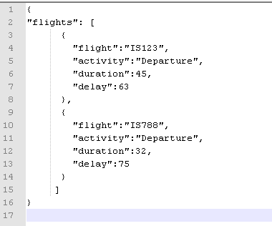

Definition of these tags are

Flight: the aircraft flight number

Activity: whether the aircraft is arriving or departing the airport

Duration: the number of seconds the aircraft needs in order to complete the activity

Delay: the number of seconds into the simulation when the aircraft asks for permission to take off or land

After input file is processed the file name would be changed to <FILENAME>.PROCESSED

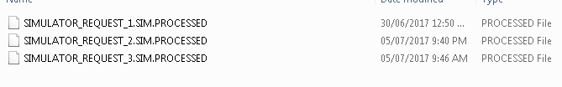

# Logs

Logs are generated inside log folder

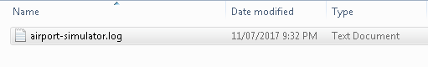

Content of the log file

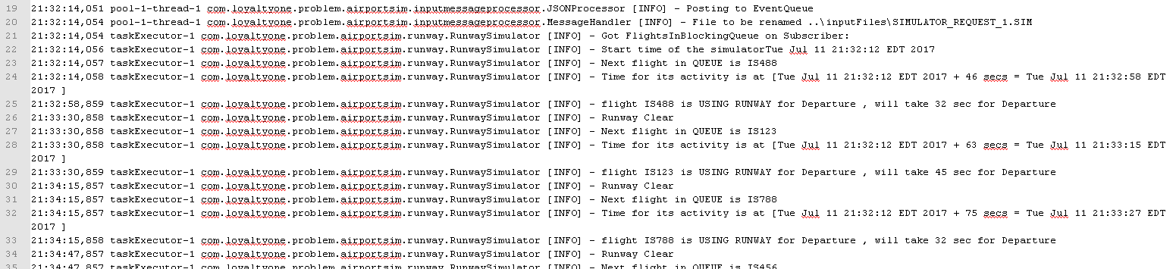

# Config Folder

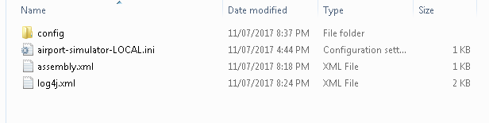

airport-simulator-LOCAL.ini

This file contains application related configuration which can be setup dynamically according to user needs. Default properties already been setup. No changes are required in this files unless user needs some advanced setup.

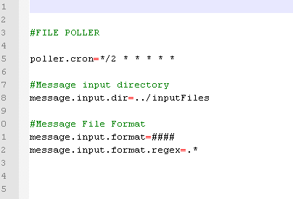

log4j.xml can be edited for advanced logging properties setup. Default properties are already been setup and required no changes unless user needs some advanced setup.

Assembly.xml – no need to change this file

# How to compile the program

Download source code from github <https://github.com/surathdey/airport-simulator>

Unzip and Go to parent folder.

Execute

mvn clean install package -Dmaven.test.skip=true

Make sure JAVA_HOME and maven path setup properly.

